The laboratory work 9

Exercise 1: Print current date and time in Python

Exercise 2: Convert string into a datetime object
For example, you received the following date in string format. Please convert it into Python’s datetime object.
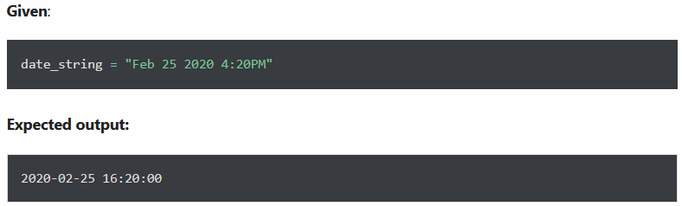

Exercise 3: Subtract a week (7 days) from a given date in Python

Given:

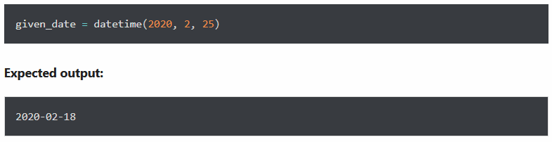

Exercise 4: Print a date in the following format

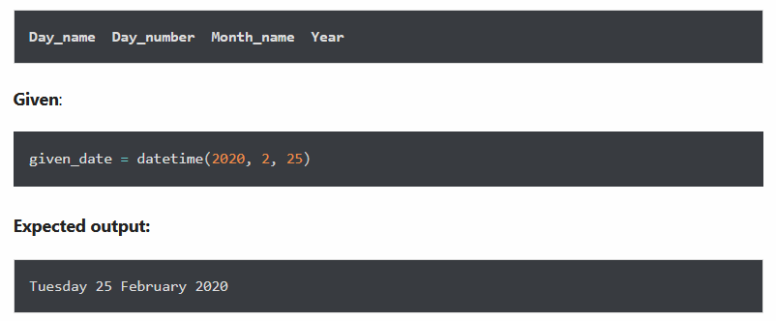

Exercise 5: Find the day of the week of a given date

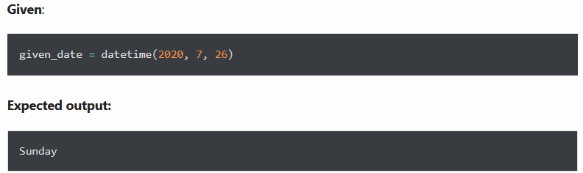

Exercise 6: Add a week (7 days) and 12 hours to a given date

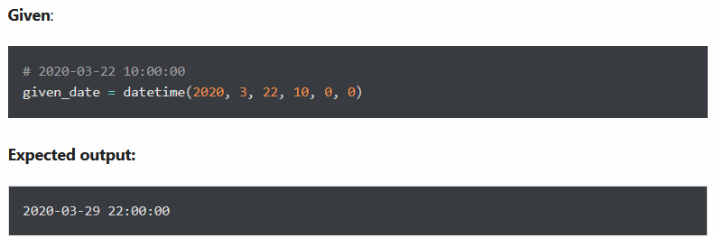

Exercise 7: Print current time in milliseconds

Exercise 8: Convert the following datetime into a string

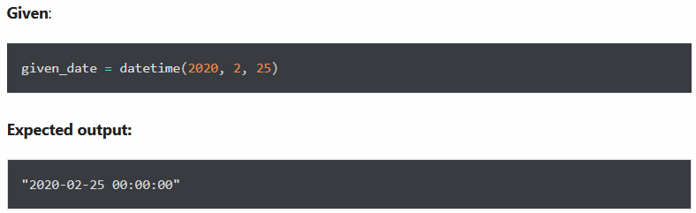

Exercise 9: Calculate the date 4 months from the current date

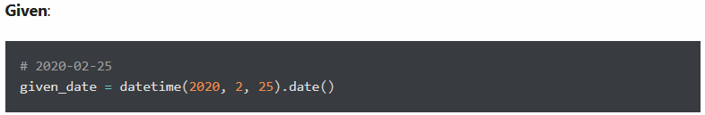

Expected output:

Exercise 10: Calculate number of days between two given dates

